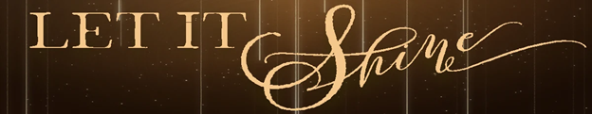

Pastor Todd Schlechty John Shines
December 9, 2018 Matthew 3:1-12

John 1:4-5 In him was life, and the life was the light of all people. ⁵The light shines in the darkness, and the darkness did not overcome it. (NRS)

Matthew 5:14-16 "You are the light of the world. A city built on a hill cannot be hid. ¹⁵No one after lighting a lamp puts it under the bushel basket, but on the lampstand, and it gives light to all in the house. ¹⁶In the same way, let your light shine before others, so that they may see your good works and give glory to your Father in heaven. (NRS)

Shining the Brightest Light

I. ______________________________________ the Light.
Matthew 3:1-2 Now in those days John the Baptist came, preaching in the wilderness of Judea, saying, ²"Repent, for the kingdom of heaven is at hand."

What to repent of?

- The feeling that I can make it fine in life without grace.
- The belief that nothing can help me.

II. ____________ for the Light – _____________________.
Matthew 3:3-4 For this is the one referred to by Isaiah the prophet when he said, "THE VOICE OF ONE CRYING IN THE WILDERNESS, 'MAKE READY THE WAY OF THE LORD, MAKE HIS PATHS STRAIGHT!'" ⁴Now John himself had a garment of camel's hair and a leather belt around his waist; and his food was locusts and wild honey.

III. ______________________________where the Light Is.
Matthew 3:5-6 Then Jerusalem was going out to him, and all Judea and all the district around the Jordan; ⁶and they were being baptized by him in the Jordan River, as they confessed their sins.

IV. ___________________________ you are not the Light.
Matthew 3:11-12 … As for me, I baptize you with water for repentance, but He who is coming after me is mightier than I, and I am not fit to remove His sandals; He will baptize you with the Holy Spirit and fire. ¹²His winnowing fork is in His hand, and He will thoroughly clear His threshing floor; and He will gather His wheat into the barn, but He will burn up the chaff with unquenchable fire."

Point:

Doggy Bag: Something to take home and chew on!

- What are the dim places in your life? What is it that keeps you from experiencing the light of life you were made for?
- When are you tempted to live for what others think of you? When do you get your perception of self from what others think of you? When do you get your perception of self from what Christ thinks of you?
- What would it look like in your life to move toward the Light? What might be your next step? When could you take that step?

If you’d like to talk personally and confidentially w/Pastor Todd about your relationship with Christ, please email pastortodd@thevineva.org to set up an appointment.

