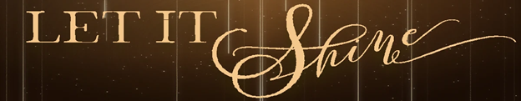

Pastor Todd Schlechty Mary Shines
December 16, 2018 Luke 1:26-38

John 1:4-5 In him was life, and the life was the light of all people. ⁵The light shines in the darkness, and the darkness did not overcome it. (NRS)

Matthew 5:14-16 "You are the light of the world. A city built on a hill cannot be hid. ¹⁵No one after lighting a lamp puts it under the bushel basket, but on the lampstand, and it gives light to all in the house. ¹⁶In the same way, let your light shine before others, so that they may see your good works and give glory to your Father in heaven. (NRS)

Receiving the Light of Christmas:

I. Expect to be _________________________by the Light.
Luke 1:26-29 Now in the sixth month the angel Gabriel was sent from God to a city in Galilee called Nazareth, ²⁷to a virgin engaged to a man whose name was Joseph, of the descendants of David; and the virgin's name was Mary. ²⁸And coming in, he said to her, "Greetings, favored one! The Lord is with you." ²⁹But she was very perplexed at this statement, and kept pondering what kind of salutation this was.

II. It’s normal_____________________________the Light.
Luke 1:30-34 The angel said to her, "Do not be afraid, Mary; for you have found favor with God. ³¹And behold, you will conceive in your womb and bear a son, and you shall name Him Jesus. ³²He will be great and will be called the Son of the Most High; and the Lord God will give Him the throne of His father David; ³³and He will reign over the house of Jacob forever, and His kingdom will have no end." ³⁴Mary said to the angel, "How can this be, since I am a virgin?"

III. We must______________________________ the Light.
Luke 1:35-38 The angel answered and said to her, "The Holy Spirit will come upon you, and the power of the Most High will overshadow you; and for that reason the holy Child shall be called the Son of God. ³⁶"And behold, even your relative Elizabeth has also conceived a son in her old age; and she who was called barren is now in her sixth month. ³⁷For nothing will be impossible with God." ³⁸And Mary said, "Behold, the bondslave of the Lord; may it be done to me according to your word." And the angel departed from her.

How? _________________________________________

Point:

Doggy Bag: Something to take home and chew on!

- When have you questioned God’s grace? When have you questioned God’s love for you? God’s call for your life? God’s plan for your future?
- What part of your life seems outside of God’s grace? What part of your life seems too bleak or dim for God to touch (outside of God’s light)? What part of your life seems like God would never show up there?
- What unexpected ways have you experienced grace in the past?
- How will you respond to God’s light when Christ shows up this Christmas?

If you’d like to talk personally and confidentially w/Pastor Todd about your relationship with Christ, please email pastortodd@thevineva.org to set up an appointment.

