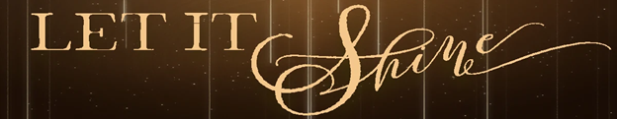

Pastor Melissa Dunlap Follow the Light
January 6, 2019 Matthew 2:1-12

What are your New Year’s Resolutions?

Invitation to _____________________________________
Matthew 2:1-2 After Jesus was born in Bethlehem in Judea, during the time of King Herod, Magi from the east came to Jerusalem ²and asked, “Where is the one who has been born king of the Jews? We saw his star when it rose and have come to worship him.”

Invitation to _____________________________________
Matthew 2:3-8 When King Herod heard this he was disturbed, and all Jerusalem with him. ⁴ When he had called together all the people’s chief priests and teachers of the law, he asked them where the Messiah was to be born. ⁵“In Bethlehem in Judea,” they replied, “for this is what the prophet has written:

⁶“‘But you, Bethlehem, in the land of Judah,
are by no means least among the rulers of Judah;
for out of you will come a ruler
who will shepherd my people Israel.’”

⁷ Then Herod called the Magi secretly and found out from them the exact time the star had appeared. ⁸ He sent them to Bethlehem and said, “Go and search carefully for the child. As soon as you find him, report to me, so that I too may go and worship him.”

Invitation to _____________________________________
Matthew 2:9-12 ⁹After they had heard the king, they went on their way, and the star they had seen when it rose went ahead of them until it stopped over the place where the child was. ¹⁰When they saw the star, they were overjoyed. ¹¹On coming to the house, they saw the child with his mother Mary, and they bowed down and worshiped him. Then they opened their treasures and presented him with gifts of gold, frankincense and myrrh. ¹² And having been warned in a dream not to go back to Herod, they returned to their country by another route.

Point:

A Covenant Prayer in the Wesleyan Tradition (Contemporary Version)

I am no longer my own, but yours.
Put me to what you will, place me with whom you will.
Put me to doing, put me to suffering.
Let me be put to work for you or set aside for you,
Praised for you or criticized for you.
Let me be full, let me be empty.
Let me have all things, let me have nothing.
I freely and fully surrender all things to your glory and service.
And now, O wonderful and holy God,
Creator, Redeemer, and Sustainer,
you are mine, and I am yours.
So be it.
And the covenant which I have made on earth,
Let it also be made in heaven. Amen.

Doggy Bag: Something to take home and chew on!

- What sign is God inviting you to pursue this year? Are you ready to follow and worship?
- How can you find guidance in scripture this year? Who can you invite to join you?
- How have you experienced God’s blessings when you worship?
- Reflect on the covenant prayer. What phrase stands out to you? Which one is the most challenging to you?

Consider praying this prayer on a regular basis and see how God answers it.

