Pastor Kay Hwang The Voice of God
June 24, 2018 Mark 1:9-11

What is strange about this picture?
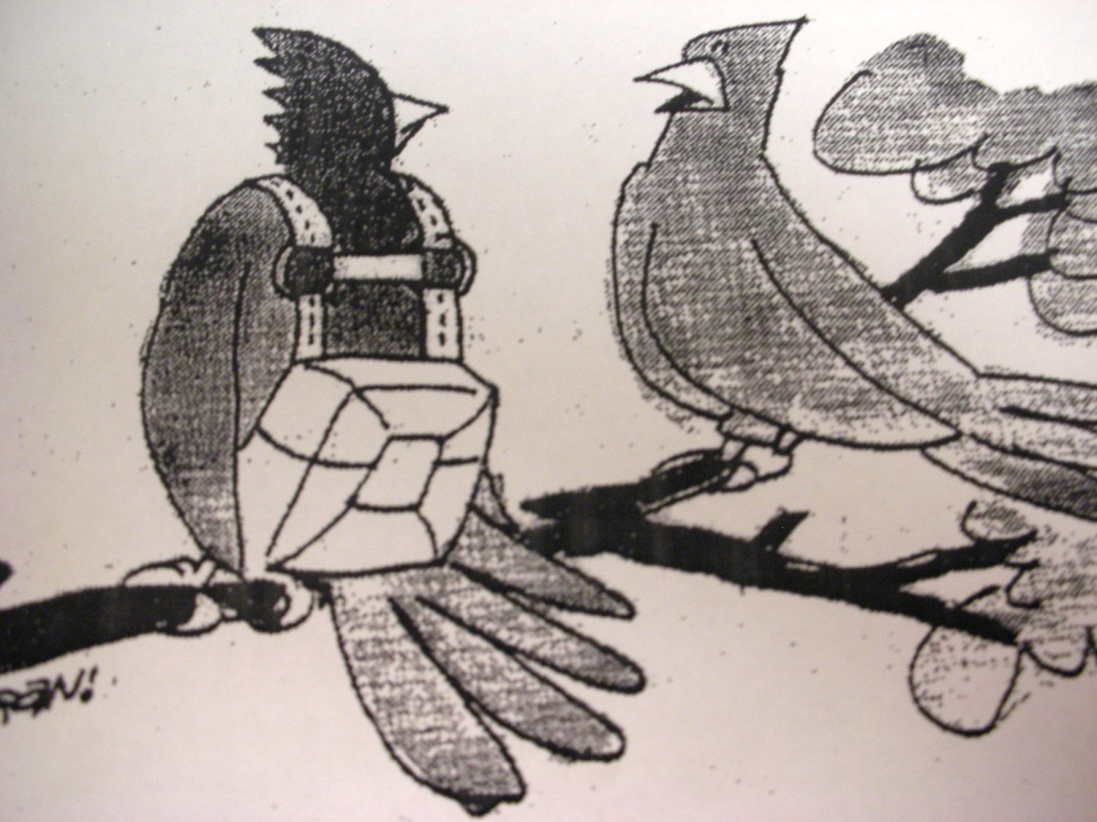

God’s life-giving voice:
Mark 1:9-11 At that time Jesus came from Nazareth in Galilee and was baptized by John in the Jordan. ¹⁰Just as Jesus was coming up out of the water, he saw heaven being torn open and the Spirit descending on him like a dove. ¹¹And a voice came from heaven: “You are my Son, whom I love; with you I am well pleased.”

I. You are my _____________________.
Mark 1:11 And a voice came from heaven, “You are my Son…”

II. Whom I ________________________.
Psalm 139:13-14 For it was you who formed my inward parts; you knit me together in my mother’s womb. ¹⁴I praise you, for I am fearfully and wonderfully made. Wonderful are your works; that I know very well.

III. With you I am ________________ _____________________.
Romans 5:8 But God shows his love for us in that while we were still sinners, Christ died for us.

Point:

Doggy Bag: Something to take home and chew on!

- How would you feel if God spoke to you the same words He spoke to Jesus?

- Can you accept and believe that “God not only loves you, but he is pleased with you?”

- How often do we speak the same words to our family, to those whom we love?

- What are the words of love and affirmation our children need to hear?

If you’d like to talk personally and confidentially w/Pastor Kay about your relationship with Christ, please email kayhwang@thevineva.org or call 703-573-5836 to set up an appointment.

