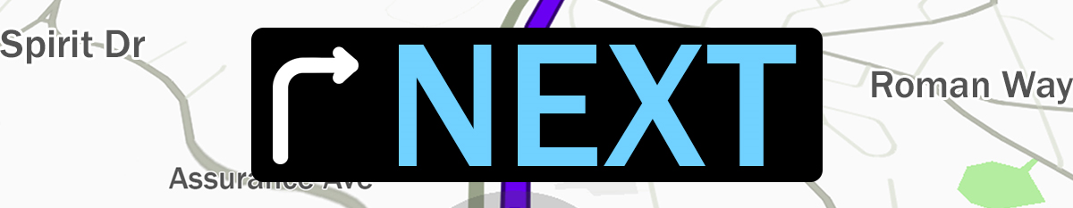
Pastor Todd Schlechty Your Next Life
June 24, 2018 Romans 6:15-7:6

What is your next?
- Plans for next vacation? ___________________________________________

- Dream for next job?_______________________________________________

- Ideas for next investment? _________________________________________

- Hopes for next step in a relationship? ________________________________

- Goals for next year in school?_______________________________________

- Goals for physical training and health?________________________________

Law vs. Spirit:
- Law-- __________________________________________________________

- Spirit-- _________________________________________________________

I. Pictures of God’s Next--(3 Metaphors for Law vs. Spirit)
- Death & ____________________________________________(Rom. 6:1-14)

- Slave & ____________________________________________(Rom. 6:15-23)

- Married & ____________________________________________(Rom. 7:1-3)

II. From Slave to _______________________________________
Romans 6:15-23 What then? Shall we sin because we are not under law but under grace? May it never be! ¹⁶Do you not know that when you present yourselves to someone as slaves for obedience, you are slaves of the one whom you obey, either of sin resulting in death, or of obedience resulting in righteousness? ¹⁷But thanks be to God that though you were slaves of sin, you became obedient from the heart to that form of teaching to which you were committed, ¹⁸and having been freed from sin, you became slaves of righteousness. ¹⁹I am speaking in human terms because of the weakness of your flesh. For just as you presented your members as slaves to impurity and to lawlessness, resulting in further lawlessness, so now present your members as slaves to righteousness, resulting in sanctification. ²⁰For when you were slaves of sin, you were free in regard to righteousness. ²¹Therefore what benefit were you then deriving from the things of which you are now ashamed? For the outcome of those things is death. ²²But now having been freed from sin and enslaved to God, you derive your benefit, resulting in sanctification, and the outcome, eternal life. ²³For the wages of sin is death, but the free gift of God is eternal life in Christ Jesus our Lord.
- Slave-- _________________________________________________________
- Free, Freed, Released-- ____________________________________________

III. From Married to _____________________________________
Romans 7:1-3 Or do you not know, brethren (for I am speaking to those who know the law), that the law has jurisdiction over a person as long as he lives? ²For the married woman is bound by law to her husband while he is living; but if her husband dies, she is released from the law concerning the husband. ³So then, if while her husband is living she is joined to another man, she shall be called an adulteress; but if her husband dies, she is free from the law, so that she is not an adulteress though she is joined to another man.

How do you experience your next life?
Romans 7:4-6 Therefore, my brethren, you also were made to die to the Law through the body of Christ, so that you might be joined to another, to Him who was raised from the dead, in order that we might bear fruit for God. ⁵For while we were in the flesh, the sinful passions, which were aroused by the Law, were at work in the members of our body to bear fruit for death. ⁶But now we have been released from the Law, having died to that by which we were bound, so that we serve in newness of the Spirit and not in oldness of the letter.

Point:

Doggy Bag: Something to take home and chew on!
- What is your next? What is your next step?
- What keeps you from becoming the person God created you to be on the inside?
- When do you feel free in Christ? What does that feel like?
- What steps can you take to live by the Spirit?
- Daily prayer
- Daily Bible reading
- Weekly sabbath
- Weekly large-group worship
- Weekly small-group support

If you’d like to talk personally and confidentially w/Pastor Todd about your relationship with Christ, please email pastortodd@thevineva.org or call 703-573-5836 to set up an appointment.

