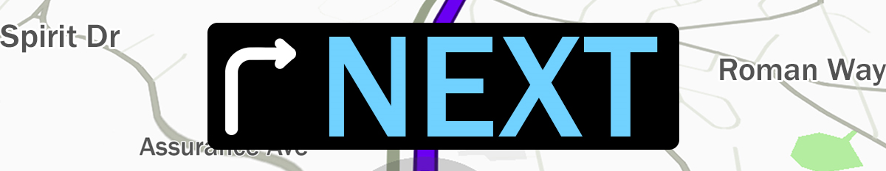

Pastor Kris Beckert Picturing What’s Next?
July 1, 2018 Romans 6:14-7:6

What is next for you? What’s most exciting about it? What’s most challenging or scary about it?

Have you ever taken a trip that didn’t turn out as you pictured?

Two directive forces in our journey:
Romans 6:14 For sin shall no longer be your master, because you are not under the law, but under grace.

1. Law--
2. Grace--

Picture What God has Next:

Picture #1: Old vs. New _____________: What’s ____________?
Romans 6:15-23 What then? Shall we sin because we are not under the law but under grace? By no means! ¹⁶Don’t you know that when you offer yourselves to someone as obedient slaves, you are slaves of the one you obey—whether you are slaves to sin, which leads to death, or to obedience, which leads to righteousness? ¹⁷But thanks be to God that, though you used to be slaves to sin, you have come to obey from your heart the pattern of teaching that has now claimed your allegiance. ¹⁸You have been set free from sin and have become slaves to righteousness. ¹⁹I am using an example from everyday life because of your human limitations. Just as you used to offer yourselves as slaves to impurity and to ever-increasing wickedness, so now offer yourselves as slaves to righteousness leading to holiness. ²⁰When you were slaves to sin, you were free from the control of righteousness. ²¹What benefit did you reap at that time from the things you are now ashamed of? Those things result in death! ²²But now that you have been set free from sin and have become slaves of God, the benefit you reap leads to sanctification, and the result is eternal life. ²³For the wages of sin is death, but the gift of God is eternal life in Christ Jesus our Lord.
- Live like you’re __________________________________________________
- Remember _____________________________________________________
- Know where ____________________________________________________

Picture #2: Old vs. New _____________: What’s ____________?
Romans 7:1-4 Do you not know, brothers and sisters—for I am speaking to those who know the law—that the law has jurisdiction over someone only as long as that person lives? ²For example, by law a married woman is bound to her husband as long as he is alive, but if her husband dies, she is released from the law that binds her to him. ³So then, if she has sexual relations with another man while her husband is still alive, she is called an adulteress. But if her husband dies, she is released from that law and is not an adulteress if she marries another man. ⁴So, my brothers and sisters, you also died to the law through the body of Christ, that you might belong to another, to him who was raised from the dead, in order that we might bear fruit for God.

Picture #3: Old vs. New _____________: What’s ____________?
Romans 7:5-6 For when we were in the realm of the flesh, the sinful passions aroused by the law were at work in us, so that we bore fruit for death. ⁶But now, by dying to what once bound us, we have been released from the law so that we serve in the new way of the Spirit, and not in the old way of the written code.

Big Idea:

Doggy Bag: Something to take home and chew on!
- Why are you doing what you’re doing? What “master” are you allowing to govern or direct your “next?”
- Do you tend to view Christianity as being about rules or relationship? Have you experienced the freedom of Christ?
- What would it look like to be faithful to Christ in this season?
- What fruit is evident in your life? What would it take for you to allow God to produce life-giving fruit?
- What intentional step can you take to begin to deepen your faith and discover what God has next for you? Examples: Attending worship weekly, praying daily, reading the Bible, serving, joining a small group.

If you’d like to talk personally and confidentially w/Pastor Kris about your relationship with Christ, please email krisbeckert@thevineva.org or call 215-237-4959 to set up an appointment.

