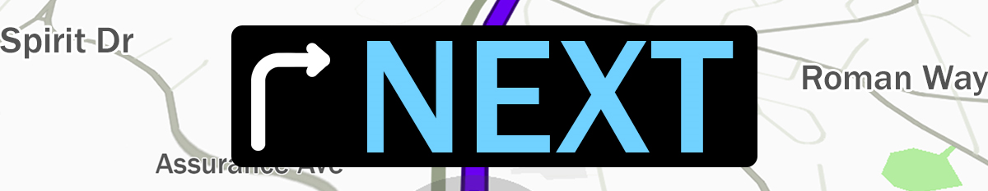

Pastor Kris Beckert Stuck On What’s Next
July 8, 2018 Romans 7:5-8:2

Have you ever gotten stuck somewhere?

In what ways do you feel stuck in life?

Romans 6-8: A journey to God’s “next.”

- Romans 6:1-14 God’s next _______________________________________
- Romans 6:14-7:6 God’s next _______________________________________

Romans 7:5-6 For when we were in the realm of the flesh, the sinful passions aroused by the law were at work in us, so that we bore fruit for death. ⁶But now, by dying to what once bound us, we have been released from the law so that we serve in the new way of the Spirit, and not in the old way of the written code.

I. The______________________________________ of Stuckness
Romans 7:7-13 What shall we say, then? Is the law sinful? Certainly not! Nevertheless, I would not have known what sin was had it not been for the law. For I would not have known what coveting really was if the law had not said, “You shall not covet.” ⁸But sin, seizing the opportunity afforded by the commandment, produced in me every kind of coveting. For apart from the law, sin was dead. ⁹Once I was alive apart from the law; but when the commandment came, sin sprang to life and I died. ¹⁰I found that the very commandment that was intended to bring life actually brought death. ¹¹For sin, seizing the opportunity afforded by the commandment, deceived me, and through the commandment put me to death. ¹²So then, the law is holy, and the commandment is holy, righteous and good. ¹³Did that which is good, then, become death to me? By no means! Nevertheless, in order that sin might be recognized as sin, it used what is good to bring about my death, so that through the commandment sin might become utterly sinful.

- Total independence results in_______________________________________
- Nobody is exempt from____________________________________________

II. The _____________________________________ of Stuckness
Romans 7:14-24 We know that the law is spiritual; but I am unspiritual, sold as a slave to sin. ¹⁵I do not understand what I do. For what I want to do I do not do, but what I hate I do. ¹⁶And if I do what I do not want to do, I agree that the law is good. ¹⁷As it is, it is no longer I myself who do it, but it is sin living in me. ¹⁸For I know that good itself does not dwell in me, that is, in my sinful nature. For I have the desire to do what is good, but I cannot carry it out. ¹⁹For I do not do the good I want to do, but the evil I do not want to do—this I keep on doing. ²⁰Now if I do what I do not want to do, it is no longer I who do it, but it is sin living in me that does it. ²¹So I find this law at work: Although I want to do good, evil is right there with me. ²²For in my inner being I delight in God’s law; ²³but I see another law at work in me, waging war against the law of my mind and making me a prisoner of the law of sin at work within me. ²⁴What a wretched man I am! Who will rescue me from this body that is subject to death?

- Stuck on ________________________________________________ (v.14-17)
- Stuck in_________________________________________________ (v.18-20)
- Stuck in_________________________________________________ (v.21-23)
- Stuck in____________________________________________________(v.24)

III. The _____________________________________ to Stuckness
Romans 7:25-8:2 Thanks be to God, who delivers me through Jesus Christ our Lord! So then, I myself in my mind am a slave to God’s law, but in my sinful nature a slave to the law of sin. ¹Therefore, there is now no condemnation for those who are in Christ Jesus, ²because through Christ Jesus the law of the Spirit who gives life has set you free from the law of sin and death.

Big Idea:

Doggy Bag: Something to take home and chew on!
- What’s your “next?” Where are you stuck in life?
- Have you ever assumed certain problems were for other people, only later to find yourself stuck in one of them?
- What is the most common source of your stuckness—confusion, failure, chasing the wrong standard, being stuck in your own skin?
- How have you been chasing freedom or perfection in life? How has independence, fixing things on your own, deepened your stuckness?
- When have you been most dependent on Christ? What does it mean, look like, and feel like, to experience freedom by depending on Him?

If you’d like to talk personally and confidentially w/ Pastor Kris about your relationship with Christ, please email krisbeckert@thevineva.org to set up an appointment.

