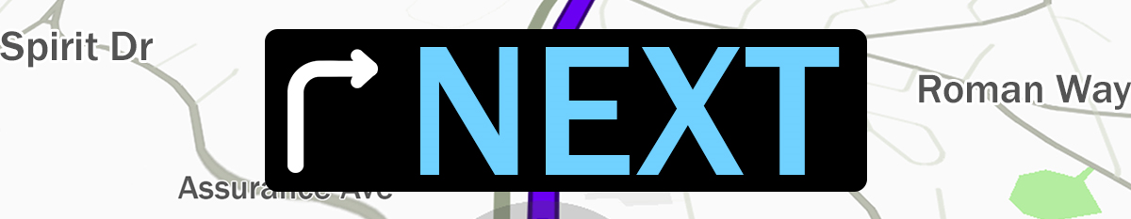
Pastor Todd Schlechty The Way Forward
July 8, 2018 Romans 7:7-8:3

What is your next?
- Financial Life ____________________________________________________
- Educational Life__________________________________________________
- Personal Life ____________________________________________________
- Career _________________________________________________________
- Spiritual Life ____________________________________________________
How to grow Spiritually?
“Life under the Law” vs. “Life under grace” (6:15)
“Life in the flesh” (7:5) vs. “Life in the Spirit” (7:6)
The Wrong Way to your Next (best) Life: ____________________
- The Law is _____________ but can’t make us _____________.
Romans 7:7-13 What shall we say then? Is the Law sin? May it never be! On the contrary, I would not have come to know sin except through the Law; for I would not have known about coveting if the Law had not said, "YOU SHALL NOT COVET." ⁸But sin, taking opportunity through the commandment, produced in me coveting of every kind; for apart from the Law sin is dead. ⁹I was once alive apart from the Law; but when the commandment came, sin became alive and I died; ¹⁰and this commandment, which was to result in life, proved to result in death for me; ¹¹for sin, taking an opportunity through the commandment, deceived me and through it killed me. ¹²So then, the Law is holy, and the commandment is holy and righteous and good. ¹³Therefore did that which is good become a cause of death for me? May it never be! Rather it was sin, in order that it might be shown to be sin by effecting my death through that which is good, so that through the commandment sin would become utterly sinful.

- Law/Commandment--
o The Law reveals sin (V. 7)
o The Law is holy… and righteous and good. (V. 12)
o But the Law can’t make us holy. (V. 13)
- Sin, sinful--

II. The Law is _______________, but we are ________________.
Romans 7:14-25 For we know that the Law is spiritual, but I am of flesh, sold into bondage to sin. ¹⁵For what I am doing, I do not understand; for I am not practicing what I would like to do, but I am doing the very thing I hate. ¹⁶But if I do the very thing I do not want to do, I agree with the Law, confessing that the Law is good. ¹⁷So now, no longer am I the one doing it, but sin which dwells in me. ¹⁸For I know that nothing good dwells in me, that is, in my flesh; for the willing is present in me, but the doing of the good is not. ¹⁹For the good that I want, I do not do, but I practice the very evil that I do not want. ²⁰But if I am doing the very thing I do not want, I am no longer the one doing it, but sin which dwells in me. ²¹I find then the principle (law) that evil is present in me, the one who wants to do good. ²²For I joyfully concur with the law of God in the inner man, ²³but I see a different law in the members of my body, waging war against the law of my mind and making me a prisoner of the law of sin which is in my members. ²⁴Wretched man that I am! Who will set me free from the body of this death? ²⁵Thanks be to God through Jesus Christ our Lord! So then, on the one hand I myself with my mind am serving the law of God, but on the other, with my flesh the law of sin.

III. The Law was given to lead us to__________ & ____________.
Romans 8:1-3 Therefore there is now no condemnation for those who are in Christ Jesus. ²For the law of the Spirit of life in Christ Jesus has set you free from the law of sin and of death. ³For what the Law could not do, weak as it was through the flesh, God did: sending His own Son in the likeness of sinful flesh and as an offering for sin, He condemned sin in the flesh,

Point:

Doggy Bag: Something to take home and chew on!
- What is next in your relationship with the Spirit of God? What is a step you can take to grow deeper with Christ?
- What is God’s next for your devotional life?
- What’s next in your service to God?
- What’s next in your witness for Christ?
- What’s next in developing the Spiritual gifts that are within you?
- What’s next in your stewardship?

If you’d like to talk personally and confidentially w/Pastor Todd about your relationship with Christ, please email pastortodd@thevineva.org or call 703-573-5836 to set up an appointment.

