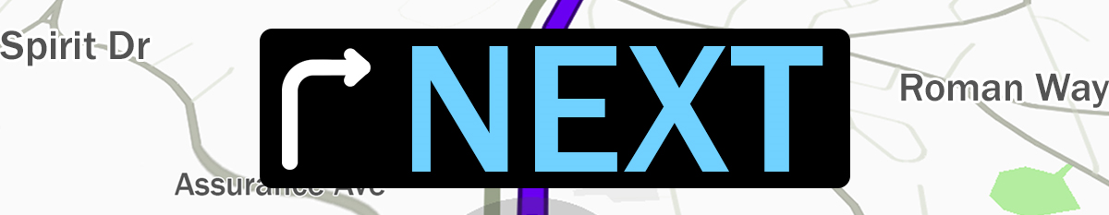

Pastor Todd Schlechty Life in the Spirit
July 15, 2018 Romans 8:1-17

What is your next?

How to grow Spiritually?

“Life under the ________________” vs. “Life under ____________________”(6:15)
“Life in the_________________” (7:5) vs. “Life in the ___________________” (7:6)

The Keys to Your Spiritual Next

I. Its Source: __________________________________________.
Romans 8:1-4 Therefore there is now no condemnation for those who are in Christ Jesus. ²For the law of the Spirit of life in Christ Jesus has set you free from the law of sin and of death. ³For what the Law could not do, weak as it was through the flesh, God did: sending His own Son in the likeness of sinful flesh and as an offering for sin, He condemned sin in the flesh, ⁴so that the requirement of the Law might be fulfilled in us, who do not walk according to the flesh but according to the Spirit.

- Not God’s Law, but God’s Spirit.
- Not our flesh, but God’s Spirit.

II. Its Focus: __________________________________________.
Romans 8:5-8 For those who are according to the flesh set their minds on the things of the flesh, but those who are according to the Spirit, the things of the Spirit. ⁶For the mind set on the flesh is death, but the mind set on the Spirit is life and peace, ⁷because the mind set on the flesh is hostile toward God; for it does not subject itself to the law of God, for it is not even able to do so, ⁸and those who are in the flesh cannot please God.

Gal. 5:19-21 Now the deeds of the flesh are evident, which are: immorality, impurity, sensuality, ²⁰idolatry, sorcery, enmities, strife, jealousy, outbursts of anger, disputes, dissensions, factions, ²¹envying, drunkenness, carousing, and things like these, of which I forewarn you, just as I have forewarned you, that those who practice such things will not inherit the kingdom of God.

III. Its Promise: ________________________________________.
Romans 8:9-11 However, you are not in the flesh but in the Spirit, if indeed the Spirit of God dwells in you. But if anyone does not have the Spirit of Christ, he does not belong to Him. ¹⁰If Christ is in you, though the body is dead because of sin, yet the spirit is alive because of righteousness. ¹¹But if the Spirit of Him who raised Jesus from the dead dwells in you, He who raised Christ Jesus from the dead will also give life to your mortal bodies through His Spirit who dwells in you.

IV. Its Obligation: ______________________________________.
Romans 8:12-13 So then, brethren, we are under obligation, not to the flesh, to live according to the flesh-- ¹³for if you are living according to the flesh, you must die; but if by the Spirit you are putting to death the deeds of the body, you will live.

VI. Its Relationship: ____________________________________.

Romans 8:14-17 For all who are being led by the Spirit of God, these are sons of God. ¹⁵For you have not received a spirit of slavery leading to fear again, but you have received a spirit of adoption as sons by which we cry out, "Abba! Father!" ¹⁶The Spirit Himself testifies with our spirit that we are children of God, ¹⁷and if children, heirs also, heirs of God and fellow heirs with Christ, if indeed we suffer with Him so that we may also be glorified with Him.

Point:

Doggy Bag: Something to take home and chew on!
- What is the source of your life? (Money, entertainment, sports) What would it look like if the Spirit were the source of your life?
- What is your focus in life? How do “things of the flesh” become the focus of your life? What would it look like if “things of the Spirit” became the focus of your life?
- What promises do you count on in life? Promises at work? Social security? Life insurance? What would it look like if you trusted in God’s promise of life?
- What are your obligations in life? What would happen if your primary obligation in life was to live by the Spirit?
- Where do you find your identity in life? As a parent? Worker? Citizen? Soldier? What would change if you saw your primary identity as a child of God?

If you’d like to talk personally and confidentially w/ Pastor Todd about your relationship with Christ, please email pastortodd@thevineva.org to set up an appointment.

