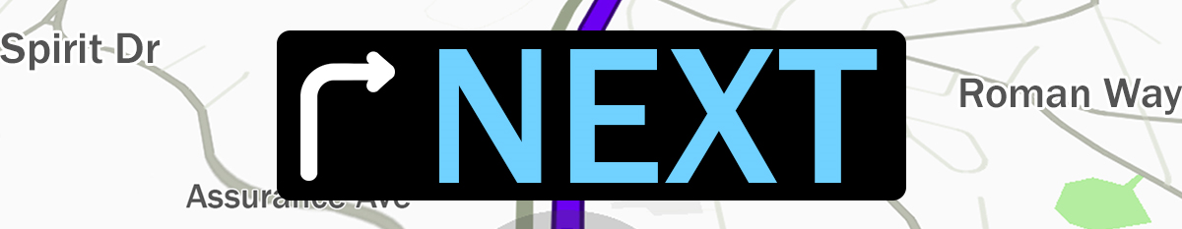
Pastor Kris Beckert Discerning What’s Next
July 15, 2018 Romans 8:1-17

How do you know what God wants you to do next?

Two cautions when trying to determine God’s “next:”
- Determining God’s “next” is not ____________________________________.
- Sometimes there are multiple______________________________________.

As you discern what’s next, remember:
Romans 8:1-4 Therefore, there is now no condemnation for those who are in Christ Jesus, ²because through Christ Jesus the law of the Spirit who gives life has set you free from the law of sin and death. ³For what the law was powerless to do because it was weakened by the flesh, God did by sending his own Son in the likeness of sinful flesh to be a sin offering. And so he condemned sin in the flesh, ⁴in order that the righteous requirement of the law might be fully met in us, who do not live according to the flesh but according to the Spirit.

1. You are ________________________________________________________
2. You have _______________________________________________________
3. You can ________________________________________________________

The Means of the Spirit’s Guidance:

Light #1: ______________________________________________
Romans 8:5-6 Those who live according to the flesh have their minds set on what the flesh desires; but those who live in accordance with the Spirit have their minds set on what the Spirit desires. ⁶The mind governed by the flesh is death, but the mind governed by the Spirit is life and peace.

Light #2: ______________________________________________
Romans 8:7-8 The mind governed by the flesh is hostile to God; it does not submit to God’s law, nor can it do so. ⁸Those who are in the realm of the flesh can’t please God.

Light #3: ______________________________________________
Romans 8:9-11 You, however, are not in the realm of the flesh but are in the realm of the Spirit, if indeed the Spirit of God lives in you. And if anyone does not have the Spirit of Christ, they do not belong to Christ. ¹⁰But if Christ is in you, then even though your body is subject to death because of sin, the Spirit gives life because of righteousness. ¹¹And if the Spirit of him who raised Jesus from the dead is living in you, he who raised Christ from the dead will also give life to your mortal bodies because of his Spirit who lives in you.

Light #4: ______________________________________________
Romans 8:12-13 Therefore, brothers and sisters, we have an obligation—but it is not to the flesh, to live according to it. ¹³For if you live according to the flesh, you will die; but if by the Spirit you put to death the misdeeds of the body, you will live.

Light #5: ______________________________________________
Romans 8:14-17 For those who are led by the Spirit of God are the children of God. ¹⁵The Spirit you received does not make you slaves, so that you live in fear again; rather, the Spirit you received brought about your adoption to sonship. And by him we cry, “Abba, Father.” ¹⁶The Spirit himself testifies with our spirit that we are God’s children. ¹⁷Now if we are children, then we are heirs—heirs of God and co-heirs with Christ, if indeed we share in his sufferings in order that we may also share in his glory.

Big Idea:

Doggy Bag: Something to take home and chew on!
- When was the last time you asked God “what should I do next?” How do you discern the Holy Spirit’s direction when making a decision?
- Why doesn’t God just point to what we should do in life?
- Do you have peace? Or when you pray does it feel like a snowglobe?
- What things govern your mind? What would happen if you took at least 5 minutes each day to read Scripture? (YouVersion app, hardcopy)
- What doors is God opening? What is he closing? What godly person/people in your life could you ask for wise counsel?
- Are the 5 means of the Spirit’s guidance aligning or are they zig-zagged right now? What does that mean? What should you do?

If you’d like to talk personally and confidentially w/Pastor Kris about your relationship with Christ, please email kris beckert@thevineva.org or call 215-237-4959 to set up an appointment.

