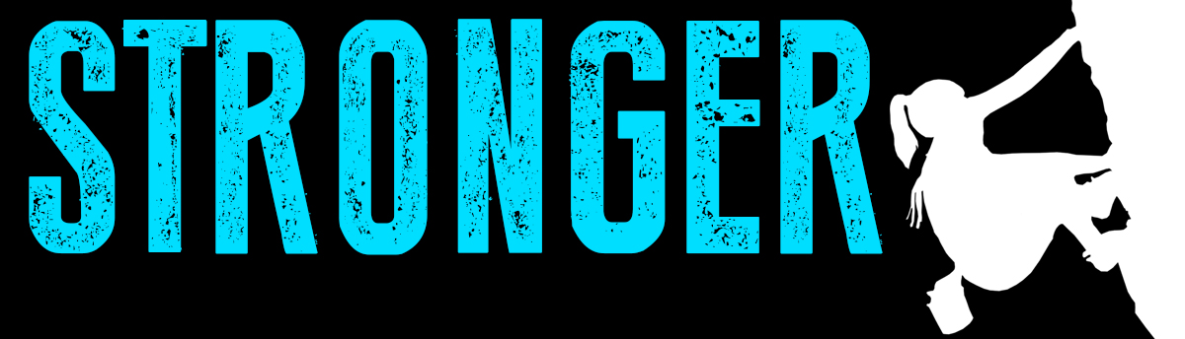
Pastor Todd Schlechty It Makes You Stronger
August 19, 2018 1 Samuel 23:1-14

What makes you stronger?

It only makes you stronger:

I. Life’s Dilemma: _________________________________
I Samuel 23:1 Then they told David, saying, "Behold, the Philistines are fighting against Keilah and are plundering the threshing floors."

II. Sometimes God calls us to take the harder path and we are _______________________________________.

I Samuel 23:2-5 So David inquired of the LORD, saying, "Shall I go and attack these Philistines?" And the LORD said to David, "Go and attack the Philistines and deliver Keilah." ³But David's men said to him, "Behold, we are afraid here in Judah. How much more then if we go to Keilah against the ranks of the Philistines?" ⁴Then David inquired of the LORD once more. And the LORD answered him and said, "Arise, go down to Keilah, for I will give the Philistines into your hand." ⁵So David and his men went to Keilah and fought with the Philistines; and he led away their livestock and struck them with a great slaughter. Thus David delivered the inhabitants of Keilah.

III. Sometimes God calls us to the hard path and things ______________________________________________
I Samuel 23:6-14 Now it came about, when Abiathar the son of Ahimelech fled to David at Keilah, that he came down with an ephod in his hand. ⁷When it was told Saul that David had come to Keilah, Saul said, "God has delivered him into my hand, for he shut himself in by entering a city with double gates and bars." ⁸So Saul summoned all the people for war, to go down to Keilah to besiege David and his men. ⁹Now David knew that Saul was plotting evil against him; so he said to Abiathar the priest, "Bring the ephod here." ¹⁰Then David said, "O LORD God of Israel, Your servant has heard for certain that Saul is seeking to come to Keilah to destroy the city on my account. ¹¹Will the men of Keilah surrender me into his hand? Will Saul come down just as Your servant has heard? O LORD God of Israel, I pray, tell Your servant." And the LORD said, "He will come down." ¹² Then David said, "Will the men of Keilah surrender me and my men into the hand of Saul?" And the LORD said, "They will surrender you." ¹³Then David and his men, about six hundred, arose and departed from Keilah, and they went wherever they could go. When it was told Saul that David had escaped from Keilah, he gave up the pursuit. ¹⁴David stayed in the wilderness in the strongholds, and remained in the hill country in the wilderness of Ziph. And Saul sought him every day, but God did not deliver him into his hand.

Point:

Doggy Bag: Something to take home and chew on!
- When have you faced an ethical dilemma of whether to get involved with a person (or situation) in need? How did you decide what to do?
- When have you served (or given) only to feel taken advantage of? Have you ever tried to make a difference in life only to find you made things harder for yourself?
- How has serving or giving in Christ’s name shaped you into a more Christ-like person? Have there been moments in your life when you have experienced God maturing you through difficulty in life?
- In what area of life might Christ be calling you to get involved and make a difference for others?

If you’d like to talk personally and confidentially w/ Pastor Todd about your relationship with Christ, please email pastortodd@thevineva.org or call 703-573-5836 to set up an appointment.

