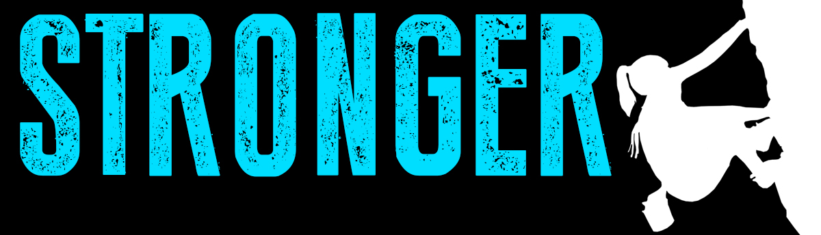

Pastor Kris Beckert Stronger Than Revenge
August 26, 2018 1 Samuel 24:1-22

When was the last time you tried to get even with someone?

What do you do when someone hurts you?

I. The irrational response: ___________ for____________
1 Samuel 24:1-2 After Saul returned from pursuing the Philistines, he was told, “David is in the Desert of En Gedi.” ²So Saul took three thousand able young men from all Israel and set out to look for David and his men near the Crags of the Wild Goats.

II. The natural response: ____________ for____________
1 Samuel 24:3-4 He came to the sheep pens along the way; a cave was there, and Saul went in to relieve himself. David and his men were far back in the cave. ⁴The men said, “This is the day the Lord spoke of when he said to you, ‘I will give your enemy into your hands for you to deal with as you wish.’” Then David crept up unnoticed and cut off a corner of Saul’s robe.

III. The remarkable response:__________for___________
1 Samuel 24:5-22 Afterward, David was conscience-stricken for having cut off a corner of his robe. ⁶He said to his men, “The Lord forbid that I should do such a thing to my master, the Lord’s anointed, or lay my hand on him; for he is the anointed of the Lord.” ⁷With these words David sharply rebuked his men and did not allow them to attack Saul. And Saul left the cave and went his way.
⁸Then David went out of the cave and called out to Saul, “My lord the king!” When Saul looked behind him, David bowed down and prostrated himself with his face to the ground. ⁹He said to Saul, “Why do you listen when men say, ‘David is bent on harming you’? ¹⁰This day you have seen with your own eyes how the Lord delivered you into my hands in the cave. Some urged me to kill you, but I spared you; I said, ‘I will not lay my hand on my lord, because he is the Lord’s anointed.’ ¹¹See, my father, look at this piece of your robe in my hand! I cut off the corner of your robe but did not kill you. See that there is nothing in my hand to indicate that I am guilty of wrongdoing or rebellion. I have not wronged you, but you are hunting me down to take my life. ¹²May the Lord judge between you and me. And may the Lord avenge the wrongs you have done to me, but my hand will not touch you. ¹³As the old saying goes, ‘From evildoers come evil deeds,’ so my hand will not touch you. ¹⁴“Against whom has the king of Israel come out? Who are you pursuing? A dead dog? A flea? ¹⁵May the Lord be our judge and decide between us. May he consider my cause and uphold it; may he vindicate me by delivering me from your hand.” ¹⁶When David finished saying this, Saul asked, “Is that your voice, David my son?” And he wept aloud. ¹⁷“You are more righteous than I,” he said. “You have treated me well, but I have treated you badly. ¹⁸You have just now told me about the good you did to me; the Lord delivered me into your hands, but you did not kill me. ¹⁹When a man finds his enemy, does he let him get away unharmed? May the Lord reward you well for the way you treated me today. ²⁰I know that you will surely be king and that the kingdom of Israel will be established in your hands. ²¹Now swear to me by the Lord that you will not kill off my descendants or wipe out my name from my father’s family.” ²²So David gave his oath to Saul. Then Saul returned home, but David and his men went up to the stronghold.

Big Idea:

Doggy Bag: Something to take home and chew on!
- When has someone tried to get even with you after you wronged him or her in some way?
- What “stories” do you tend to tell yourself that assume the worst? Could you be repaying evil for someone else’s “good”--or at least their non-malicious intent?
- How do you tend to try and get even--physical violence, destroying things, withdrawing, belittling, or holding a grudge against the person who hurt you? Or do you suppress your emotions?
- Who do you want to get even with? How are you are tempted to repay evil with evil? What is God revealing to you about that person? About yourself?
- What can you do to follow your heavenly Father’s example of returning good for evil and leaving justice to God? What if you were to begin to pray the simple prayer “God, work in this person’s life” this week?

If you’d like to talk personally and confidentially w/Pastor Kris about your relationship with Christ, please email krisbeckert@thevineva.org to set up an appointment.

