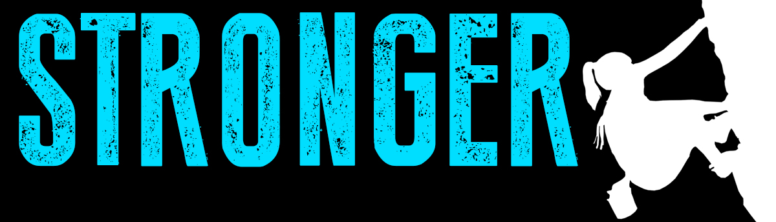
Amy Maxwell Faith and Repentance in a Cave!
August 26, 2018 1 Samuel 24:1-20

Part I.
1 Samuel 24:4 The men of David said to him, "Behold, this is the day of which the Lord said to you, 'Behold; I am about to give your enemy into your hand, and you shall do to him as it seems good to you.'" Then David arose and cut off the edge of Saul's robe secretly.

A Lie + The Truth = _______________________________

Part II.
1Samuel 24:5-7 It came about afterward that David's conscience bothered him because he had cut off the edge of Saul's robe. ⁶So he said to his men, "Far be it from me because of the Lord that I should do this thing to my lord, the Lord's anointed, to stretch out my hand against him, since he is the Lord's anointed." ⁷David persuaded his men with these words and did not allow them to rise up against Saul. And Saul arose, left the cave, and went on his way.

Listening to + obeying your conscience ______________

Part III.
1 Samuel 24:8-10 Now afterward David arose and went out of the cave and called after Saul, saying, "My lord the king!" And when Saul looked behind him, David bowed with his face to the ground and prostrated himself. ⁹David said to Saul, "Why do you listen to the words of men, saying, 'Behold, David seeks to harm you'? ¹⁰Behold, this day your eyes have seen that the Lord had given you today into my hand in the cave, and some said to kill you, but my eye had pity on you; and I said, 'I will not stretch out my hand against my lord, for he is the Lord's anointed.

Humility + Compassion lead to______________________

Part IV.
1 Samuel 24:16-20 When David had finished speaking these words to Saul, Saul said, "Is this your voice, my son David?" Then Saul lifted up his voice and wept. ¹⁷He said to David, "You are more righteous than I; for you have dealt well with me, while I have dealt wickedly with you. ¹⁸You have declared today that you have done good to me, that the Lord delivered me into your hand and yet you did not kill me. ¹⁹For if a man finds his enemy, will he let him go away safely? May the Lord therefore reward you with good in return for what you have done to me this day. ²⁰Now, behold, I know that you will surely be king, and that the kingdom of Israel will be established in your hand.

Repentance is the antidote for ______________________

Doggy Bag: Something to take home and chew on!
- Who are you at odds with in your life right now?
- Is there someone who has wronged you and you have turned your heart away or adopted an indifferent attitude towards them?
- Who might you need to repent to?
.

