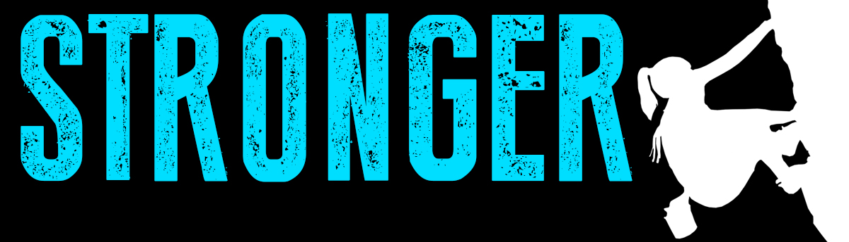

Pastor Kris Beckert Stronger From Defining Moments
September 2, 2018 1 Samuel 30:1-20

What are 3 defining moments in your life? How did they make you stronger?

Defining moments in David’s life in the book of 1 Samuel:

- Samuel anoints_____________________________________ (ch. 16)
- David faces________________________________________ (ch.17)
- David spares_______________________________________ (ch. 24)
- David meets _______________________________________ (ch. 25)
- Amalekites raid _____________________________________ (ch. 30)

Turning defining moments into stronger moments:

I. _______________ God’s strength in defining moments
1 Samuel 30:1-6 David and his men reached Ziklag on the third day. Now the Amalekites had raided the Negev and Ziklag. They had attacked Ziklag and burned it, ²and had taken captive the women and everyone else in it, both young and old. They killed none of them, but carried them off as they went on their way. ³When David and his men reached Ziklag, they found it destroyed by fire and their wives and sons and daughters taken captive. ⁴So David and his men wept aloud until they had no strength left to weep. ⁵David’s two wives had been captured—Ahinoam of Jezreel and Abigail, the widow of Nabal of Carmel. ⁶David was greatly distressed because the men were talking of stoning him; each one was bitter in spirit because of his sons and daughters. But David found strength in the Lord his God.

II. _______________ God’s strength in defining moments
1 Samuel 30:7-10 Then David said to Abiathar the priest, the son of Ahimelek, “Bring me the ephod.” Abiathar brought it to him, ⁸and David inquired of the Lord, “Shall I pursue this raiding party? Will I overtake them?” “Pursue them,” he answered. “You will certainly overtake them and succeed in the rescue.” ⁹David and the six hundred men with him came to the Besor Valley, where some stayed behind. ¹⁰Two hundred of them were too exhausted to cross the valley, but David and the other four hundred continued the pursuit.

- Strength is ______________ when it’s easier ___________________
- Strength is ______________ when it’s easier ___________________
- Strength is _______________________ than ___________________

III. ______________ God’s strength in defining moments
1 Samuel 30:11-20 They found an Egyptian in a field and brought him to David. They gave him water to drink and food to eat— ¹²part of a cake of pressed figs and two cakes of raisins. He ate and was revived, for he had not eaten any food or drunk any water for three days and three nights. ¹³David asked him, “Who do you belong to? Where do you come from?” He said, “I am an Egyptian, the slave of an Amalekite. My master abandoned me when I became ill three days ago. ¹⁴We raided the Negev of the Kerethites, some territory belonging to Judah and the Negev of Caleb. And we burned Ziklag.” ¹⁵David asked him, “Can you lead me down to this raiding party?” He answered, “Swear to me before God that you will not kill me or hand me over to my master, and I will take you down to them.” ¹⁶He led David down, and there they were, scattered over the countryside, eating, drinking and reveling because of the great amount of plunder they had taken from the land of the Philistines and from Judah. ¹⁷David fought them from dusk until the evening of the next day, and none of them got away, except four hundred young men who rode off on camels and fled. ¹⁸David recovered everything the Amalekites had taken, including his two wives. ¹⁹Nothing was missing: young or old, boy or girl, plunder or anything else they had taken. David brought everything back. ²⁰He took all the flocks and herds, and his men drove them ahead of the other livestock, saying, “This is David’s plunder.”

Big Idea:

Doggy Bag: Something to take home and chew on!
- What potential defining moment are you facing?
- Have you ever had a time in your life when you felt weak but found strength in God? What was it like? What happened?
- Right now, what is easier for you to do than not do? What is easier to not do than do? Are you more fearful of regret or making mistakes?
- Who has God connected to you as you face your defining moment? How have you witnessed God working ahead of you?
- How could God use this defining moment to make you stronger?

If you’d like to talk personally and confidentially w/Pastor Kris about your relationship with Christ, please email krisbeckert@thevineva.org to set up an appointment.

