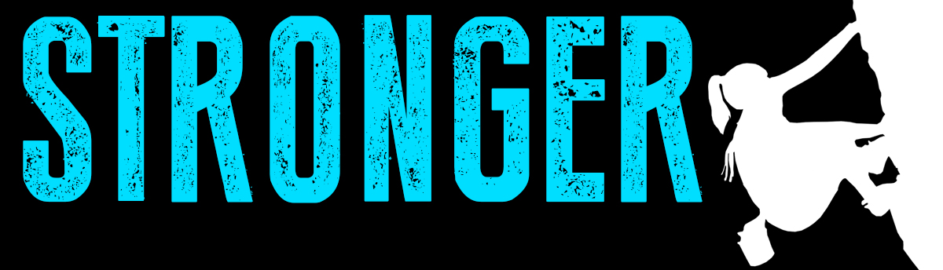

Pastor Todd Schlechty Stronger When We Share
September 9, 2018 1 Samuel 30:20-31

What do you do with your strength?

I. Strength Can __________________________________.
I Samuel 30:20 So David had captured all the sheep and the cattle which the people drove ahead of the other livestock, and they said, "This is David's spoil."

II. Stronger When We Share

A. Share with the ______________________________________________.
I Samuel 30:21-22 When David came to the two hundred men who were too exhausted to follow David, who had also been left at the brook Besor, and they went out to meet David and to meet the people who were with him, then David approached the people and greeted them. ²²Then all the wicked and worthless men among those who went with David said, "Because they did not go with us, we will not give them any of the spoil that we have recovered, except to every man his wife and his children, that they may lead them away and depart."

B. Share with the ______________________________________________.
I Samuel 30:23-25 Then David said, "You must not do so, my brothers, with what the LORD has given us, who has kept us and delivered into our hand the band that came against us. ²⁴And who will listen to you in this matter? For as his share is who goes down to the battle, so shall his share be who stays by the baggage; they shall share alike." ²⁵ So it has been from that day forward, that he made it a statute and an ordinance for Israel to this day.

C. Share with _________________________________________________.
I Samuel 30:26-31 Now when David came to Ziklag, he sent some of the spoil to the elders of Judah, to his friends, saying, "Behold, a gift for you from the spoil of the enemies of the LORD: ²⁷to those who were in Bethel, and to those who were in Ramoth of the Negev, and to those who were in Jattir, ²⁸and to those who were in Aroer, and to those who were in Siphmoth, and to those who were in Eshtemoa, ²⁹and to those who were in Racal, and to those who were in the cities of the Jerahmeelites, and to those who were in the cities of the Kenites, ³⁰and to those who were in Hormah, and to those who were in Bor-ashan, and to those who were in Athach, ³¹and to those who were in Hebron, and to all the places where David himself and his men were accustomed to go."

Eccl. 11:1-2 Cast your bread on the surface of the waters, for you will find it after many days. ²Divide your portion to seven, or even to eight, for you do not know what misfortune may occur on the earth.

Pro. 22:9 He who is generous will be blessed, for he gives some of his food to the poor.

Point:

Doggy Bag: Something to take home and chew on!
- What is your strength?
- What do you do with your strength?
- When have you used it only for yourself? Used it to share with others?
- Have you ever seen someone spoiled by God’s blessing? What does that look like?

If you’d like to talk personally and confidentially w/Pastor Todd about your relationship with Christ, please call 703-573-5836 or email pastortodd@thevineva.org to set up an appointment.

