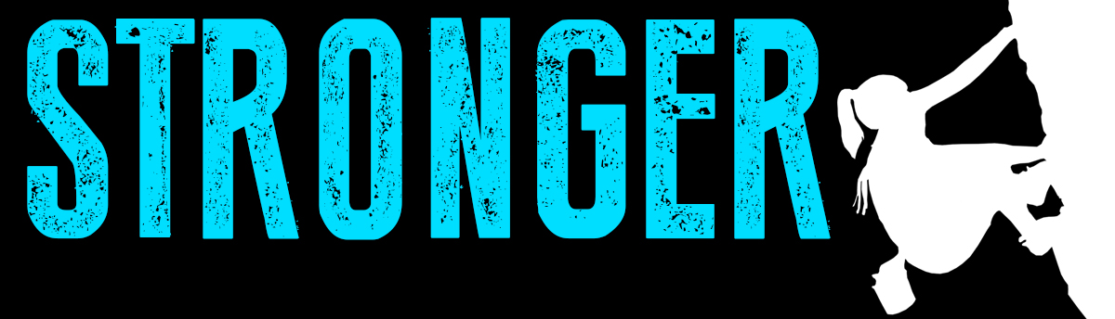
Pastor Kris Beckert Stronger Things
September 9, 2018 1 Samuel 30:20-31

What are your strengths?

What is strong in your life right now?

David’s Strengths in the book of 1 Samuel:
- Faith in God
- Leadership
- Physical strength
- Charisma
- Musician & songwriter
- Mercy

True strength is leveraging what you have:

I. Beyond_______________________________________.
1 Samuel 30:20-22 He took all the flocks and herds, and his men drove them ahead of the other livestock, saying, “This is David’s plunder.” ²¹Then David came to the two hundred men who had been too exhausted to follow him and who were left behind at the Besor Valley. They came out to meet David and the men with him. As David and his men approached, he asked them how they were. ²²But all the evil men and troublemakers among David’s followers said, “Because they did not go out with us, we will not share with them the plunder we recovered. However, each man may take his wife and children and go.”

II. Beyond those who are __________________________.
1 Samuel 30:23-25 David replied, “No, my brothers, you must not do that with what the Lord has given us. He has protected us and delivered into our hands the raiding party that came against us. ²⁴Who will listen to what you say? The share of the man who stayed with the supplies is to be the same as that of him who went down to the battle. All will share alike.” ²⁵David made this a statute and ordinance for Israel from that day to this.

III. Beyond those who are__________________________.
1 Samuel 30:26-31 When David reached Ziklag, he sent some of the plunder to the elders of Judah, who were his friends, saying, “Here is a gift for you from the plunder of the Lord’s enemies.” ²⁷David sent it to those who were in Bethel, Ramoth Negev and Jattir; ²⁸to those in Aroer, Siphmoth, Eshtemoa ²⁹and Rakal; to those in the towns of the Jerahmeelites and the Kenites; ³⁰to those in Hormah, Bor Ashan, Athak ³¹and Hebron; and to those in all the other places where he and his men had roamed.

Big Idea:

Doggy Bag: Something to take home and chew on!
- What is strong in your life right now? How are you using it?
- What do you feel entitled to? Why? How could this feeling of entitlement be getting in the way of what God wants to do in you and through you?
- In what ways do you believe you are better than others? How would seeing what you have as what “the Lord has given” change how you treat and interact with those around you?
- When was a time you experienced God working through you to impact a person or people beyond you? How did it feel? If someone looked at how you use your strengths, would they say you are building your own Kingdom or God’s?
- How could you begin to leverage one of your strengths (position, skills, personality, finances, home, family, talents, etc.) for the sake of someone else this week?

If you’d like to talk personally and confidentially w/ Pastor Kris about your relationship with Christ, please email krisbeckert@thevineva.org to set up an appointment.

