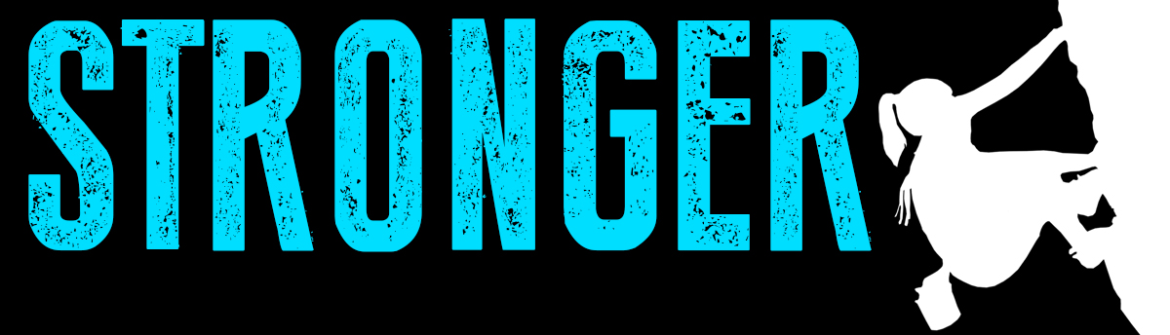

Pastor Kris Beckert Stronger Core
September 16, 2018 Acts 15:1-19

What are the effects of a weak core? Why does the core matter?

The Question at the Core: __________________________
Acts 15:1-2 Certain people came down from Judea to Antioch and were teaching the believers: “Unless you are circumcised, according to the custom taught by Moses, you cannot be saved.” ²This brought Paul and Barnabas into sharp dispute and debate with them. So Paul and Barnabas were appointed, along with some other believers, to go up to Jerusalem to see the apostles and elders about this question…

Acts 15:6-19 The apostles and elders met to consider this question. ⁷After much discussion, Peter got up and addressed them: “Brothers, you know that some time ago God made a choice among you that the Gentiles might hear from my lips the message of the gospel and believe. ⁸God, who knows the heart, showed that he accepted them by giving the Holy Spirit to them, just as he did to us. ⁹He did not discriminate between us and them, for he purified their hearts by faith. ¹⁰Now then, why do you try to test God by putting on the necks of Gentiles a yoke that neither we nor our ancestors have been able to bear? ¹¹No! We believe it is through the grace of our Lord Jesus that we are saved, just as they are.” ¹²The whole assembly became silent as they listened to Barnabas and Paul telling about the signs and wonders God had done among the Gentiles through them. ¹³When they finished, James spoke up… ¹⁹“It is my judgment, therefore, that we should not make it difficult for the Gentiles who are turning to God…”

At the Core of Vine Church:

1. Relaying a _____________________________ attitude.
(Matthew 9:10-13)
2. Rooted in _____________________________________.
(Matthew 13:51-53; Matthew. 5:17-19, II Timothy 3:16-17)

3. Relevant ______________________________________.
(Matthew 13:51-53; I Corinthians 9:19-23; Galatians 6:14-15)

4. Real and ______________________________________.
(Philippians 4:8-9)

5. Redemptive ___________________________________.
(Romans 3:23-26; Romans 8:19-28; II Corinthian 5:17-20; Colossians 1:20-22)

6. Reaching _____________________________________.
(Matthew 28:16-20; Acts 1:7-8; Luke 10:1-12)

7. Relationally ___________________________________.
(Ephesians 4:4-6; Romans 12:3-5; I Corinthians 12:12-18)

8. Reflecting a ___________________________________.
(Matthew 10:5-20; Mark 6:7ff; Luke 10:1-12; Luke 9:1-10)

Big Idea:

Doggy Bag: Something to take home and chew on!
- What values are at the core of who you are? What tries to pull you away from living out those values?
- How has your experience of Christians and Church impacted your perception of Church?
- What barriers have you had to overcome to be part of a local church? What barriers do your friends and neighbors have about church?
- What about Vine Church is attractive to you? What next step is God calling you to in your involvement in Vine Church?
- Who in your life needs hope, community, and to know that God loves them right now? Who can you invite to next week’s Fall Kickoff?

If you’d like to talk personally and confidentially w/ Pastor Kris about your relationship with Christ, please email krisbeckert@thevineva.org to set up an appointment.

